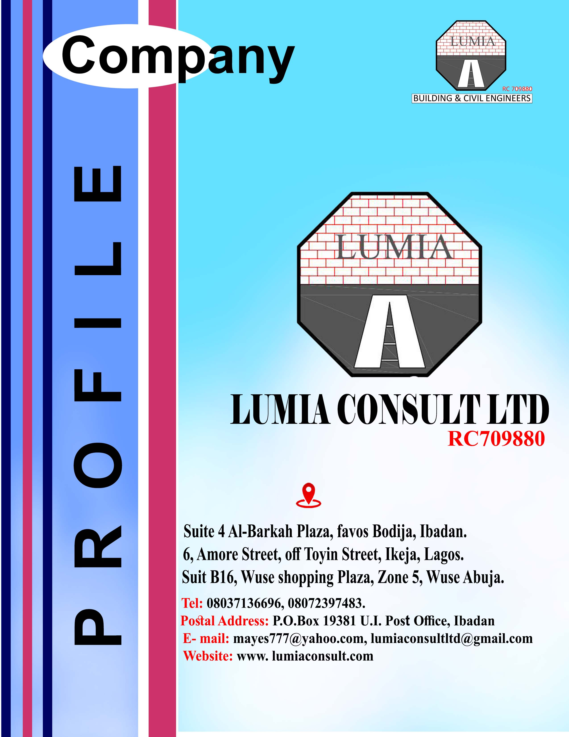



***Creating a World of Comfort and Affordability***

**VISION**

**INTRODUCTION**

**Lumia Consult limited was incorporated as a private limited liability company to offer strictly professional and specialized services in building, Civil, Structural and Telecommunication engineering among others to provide the following:**

* **Building and civil engineering works.**
* **Project Management and procurement**
* **Water scheme, rural and industrial borehole.**
* **Telecommunication infrastructural, pilling and deep foundation.**
* **Facility and property management.**
* **Maintenance management**
* **Architectural design**
* **Structural design**
* **Building production consultant.also a subsidiary of lumia-mayes construction company ltd.**

**DIRECTORS.**

**ENGR. A.O. FAKAYODE:**

**Engineer A.O. Fakayode the Chairman Lumia consult limited attendedC.A.C.Grammar School and Ibadan Polytechnic where he sat for his school certificate and Cambridge advanced Level exams respectively and passed with good grades. He later proceeded to Ahmadu Bello University where he bagged his first degree with Second Class Upper division in 1982. for his Masters degree he attended University of Lagos, Akoka, Yaba Lagos in 1987/88.**

**Engineer Fakayode is a COREN registered engineer and a member of Nigeria Society of Engineers for about two decaeds. He is married with children.**

**A talented, vibrant and intellegent man, he was employed by the then Oyo State Government as a Pupil Structural Engineer where he rose to the post of Senior Engineer before he was later seconded to DFRRI as a Project Manager Road, Building and Rural Infrastructure. His excellent perfomance in DFRRI singled him out tobe recalled back to the Ministry of works and Transport as an assistant Director Geotechnic/Structure and later promoted to the post of Deputy Director Maintenance and Foreign Assisted projects.P**

**As a result of his dynamism and versatility he performed credibility well in this post and was appointed the Director of Project Co-ordination Development in the Governors Office, to oversee all foreign assisted projects such as World Bank assisted Road and water projects, ADB assisted Agriculture projects, UNICEF assisted Rural, Water and Sanitation projects, UNESCO assisted education projects.**



***A*YEGBUSI OLUWASEUN is a Building Consultant, Risk and Safety Manager, Project Manager, an Author and External examiner, He studied Building and (BSc) in civil engineering with (MSc) in Housing Development Management. He also has a Diploma in Quantity Surveying, trained in a famous civil and structural engineering firm (Fax consult).He is presently the CEO of Lumia consult ltd and Lumia-Mayes construction company,**

**Ayegbusi Seun is a Member Nigeria Institute of Building, (MNIOB),**

**Member Council of Registered Builder of Nigeria (CORBON), Corporate Member Association of Building Engineers, (MCABE),**

**Chartered Association of Building Engineers,( C.BUILD.E),Society of professional Engineers(MSPE,P.Engr.),Member Association of Cost Engineer,(MAcostE), Certified Project Management Professional (CPMP),Certified Facility Management Professional (CFMP),Member Corporate Institute of Risk and Safety Management (CIRSM), Member Project Management Institute (PMI) and Member Management Development Administration (MDA),Doctoral Fellow Chartered Institute of Contract, Project and Facility Management, Fellow institute of personality development &customer relationship management Directors in many companies, he has attended seminars both home and abroad.**

***BSc MSc, MNIOB, CORBON, C.BUILD.E, MCABE, MSPE, P.Eng, MAcostE, CPMP, CFMP, CIRSM, PMI, MDA, FCICPFM. FIPD-CRM***

**OLUSOMOKA GOKE: The Project Development Manager of Lumia consult limited, he attended Unity Secondary School, Ado Ekiti where he obtained his Senior Secondary School Leaving Certificate, he proceeded to Federal School of Survey where he obtained his Higher National Diploma in Geo-informatic Surveying with a very good grade and he obtained post graduate diploma in Surveying from the same higher institution of learning.A registered surveyor,MNIS,SURCON,**

**He has worked in many construction companies like DSD Ltd, works department of Covenant University Sango-Otta, Business Contracting Ltd, ( a foreign construction company) who has handled many high-rise building.**

**A talented, vibrant and intellegent young man, he is married with children.**

**KEY STAFF.**

**1. FAKAYODE A.O. B.sc ( Hons) ABU, Chairman**

**MSc (LAG) MNSE,**

**COREN R 4737**

**2.AYEGBUSI O.T. BSc,MSc(U.I),FNIOB,C.BUILD.E, CEO.**

**MCABE,MSPE,P.Eng,CIRSM,**

**MAcostE,MDA,PMI,CPMP,**

**CFMP,FCICPFM,FIPD-CRM**

**CORBON R 1062**

**3. OMADIME S.I PMI,CIRSM, ACICPFM,CFMP Director, Brand&Project Manager**

**4. OLUSOMOKA OLAGOKE O MNIS, SURCON Director/Project Dev.**

**5.ARCH. ODUNLAMI .O B.Sc (Arc) Architect**

**6.ADEDOKUN ADEWALE M.Sc, ANIVS,RSV,MCAI Estate Surveyor &Valuer**

**7. JOHN OLALERE M.sc, MNIQS Site QS**

**8. AKINADE BISI M.sc, B.sc MNSE,COREN Project Engineer**

**9.DURODOLA SAMUEL PGD(Project M)HND Civil Engr. Site Engr**

**10. YEKEEN OLAITAN M. PGD(Project M),HND Building Builder**

**11. NOJEEM OLUSUNBO A MNIQS Qs**

**12.OLUFEMI KOREDE A COREN,MNSE Civil engineer**

**13.OLARENWAJU STEPHEN A COREN,MNSE Mechanical engineer**

**14.KEHINDE OLUWAFEMI O COREN,MNSE Electrical engineer**

**15.SHITTU KAMORU A MNIOB,CORBON Builder.**

**16.FAYOMI SAMUEL O Msc,FNIQS,QSRBON Quatity surveyor**

**17. OYANIRAN TAIWO (ACCA) Accountant**

**18. BARR. FISAYO FAGBEMI (LLB) Legal Adviser**

**29. ADMISTRATIVE STAFF 10**

**QUALITY ASSURANCE**

**The Lumia Consult quality assurance system is based on the principles of personnel’s involvement in carefully considered decisions and the matching of personnel with the assigned work requirement including necessary improvement of performance.**

**The principle requires that procedures must be followed scrupulously at each project state in order to attain the set objectives and achieve constant improvement. Each project is controlled using internal procedures and verifications to ensure that the final result is in conformity with both of the highest quality standards and the client’s requirements. The quality of the company’s work is verified by internal and external auditing to check that the rules laid down are respected.**

**ORGANISATION CAPABILITIES**

***LUMIA CONSULT LTD* being a broad base firm has a very unique organizational style that borders on her ability to emphasize and sensitize the entire staff to always provide best delivery of all our products and services. In the light of this, we view all our products, projects, contracts and services as imperative to all our clients, as well as the brand we are out to protect.**

**We thus view each contract from a project perspective.**

**We dissect the project and begin from concept design, then engineering and construction; and we devote time to attend to often ignore details such as supplies, finance, safety, environment and even the socio-economic analysis as it impacts on the project.**

**Specifically, we are capable of providing the following;**

* **Great costumer service,**
* **Strong costumer/ client focus,**
* **Superb team work and collaboration,**
* **Overall responsibilities for project’s success,**
* **Good quality product and services,**
* **Socially responsible acts,**
* **Facilitate and resolve client concerns,**
* **Excellent presentations, communication, status update and documentation as needed,**
* **Prompt identification of risks and resolution.**

**All these being considered, we find ourselves always performing with no project abandoned.**

**We succeed where others fail.**

**At LUMIA CONSULT LTD, there are no small or big project, all project are handled with the same level of importance.**

**AREAS OF PROFESSIONAL CONCENTRATION/ BUSSINESS**

* **CIVIL/BUILDING WORKS**

**Road/ highway construction network, bridges, culvert and drainages, estate development, hotel, hospital, market/ warehouses, shopping centers, offices, residential houses, stadium, auditorium, multi-purpose halls, hotel and resorts, estates, shopping malls and complexes, civic centers, rank and file barracks etc.**

* **STRUCTURAL CONSTRUCTION WORKS:**

***LUMIA CONSULT LTD* employs experienced builders, architects, and structural engineers in this field, hence the high standards maintained in all its building projects, surface and underground sewage disposal network systems, pilling projects, landscaping and horticultural designs etc.**

* **PROFICIENCY IN CIVIL ENGINEERING CONSTRUCTIONS**

**Our company is quite proficient in the field of civil and structural construction, and prides itself of a consortium of experts (WITHIN AND OUTSIDE THE COUNTRY) with special expertise in concrete and block, structural steel buildings on raft foundations/ pilings.**

* ***LUMIA CONSULT LTD* marine structures, jetties, canals studies and irrigation works.**
* **ENVIROMENTAL ENGINEERING : sanitary and public health studies, water supply engineering, dams and impounding reservoirs, water retaining structures, water resources studies and development , water disposal, storm water management and control.**
* **GEOTECHNIC AND GEOLOGICAL STUDIES: Foundation investigation and design, soil stabilization, ground water management aquifer protection, geological survey.**
* **MECHANICAL ENGINEERING AND CONSTRUCTIONS:**

**Plant installation and upgrade: This includes plant additions, modifications, upgrades and maintenance.**

* **FABRICATION**

**Overhead shop cranes with 40 ton life capabilities**

**Spool piping**

**Production skids**

**Manifolds**

**Structural items including small decks and boat landings**

**Pipe racks, walkways, stairways, access platforms.**

***LUMIA CONSULT LTD* undertakes local/ foreign purchases for materials and equipment requirements in it projects and also maintains stock of item for its client’s requirement.**

***LUMIA CONSULT LTD* also takes up body - shop contracts for man power supply, skilled and un-skilled.**

* **INFRASTRUCTURAL WORK**

**Our civil and building works involve the following:**

**Residential development projects we design and development of corporate or individual residential, hotels, hospitals, schools, civic center, etc. Outlays such as plan, design and drawing interpretation, evaluation, and quantification and finally develops to our client taste .To make it more interesting and habitable, we set out its beautification, landscaping, flowering and street outlays. We plant trees and flowers and provides adequate and healthy environmental posture of the project.**

* **DREDGING**

**Stock piling, sweeping, reclamation and sand filling etc**

* **GENERAL SUPPLY**

**Importation and supply of general goods and services such as: teaching /learning aid equipment, digitalization and video conference equipment etc.**

**TECHNICAL COMPETENCE**

**ORGANIZATION**

***LUMIA CONSULT LTD* is a design, engineering, construction, commissioning and maintenance company that is equipped to satisfactorily execute major projects in the area of civil, building mechanical engineering, architecture and associated fields in the construction, oil/gas and allied industries.**

**TECHNICAL PARTNERSHIP AGREEMENT AND MANPOWER**

***LUMIA CONSULT LTD* provides specialized service in engineering, procurement, construction, project management, estate development, landscapping and horticulture designs.**

***LUMIA CONSULT LTD* in association with reputable companies overseas to enhance its performance in projects that requires advance technology.**

**CURRICULUM VITAE OF KEY MEMEBER OF STAFF**

**NAME: FAKAYODE, Amos Olorunfunsho**

**THESIS.**

* **Reinforcement Concrete Design for KadunaGovernmentGarden –**

**A dissertation for B.Sc award.**

* **The Behavious of Box–Girder Bridges–A dissertation for M.Sc award.**

**WORK EXPERIENCE**

* **Ette Aro and Partners, Consulting Engineers, Lagos – June – Sept 1980.**

**Industrial Attachement.**

* **Rudiment of Structural Design and Detailing.**
* **Design and Supervision of Ilaro Polytechnic.**
* **Kike Eke and Sons. NYSC Sept. 1982–August 1983**
* **Construction of Biology and Physics Laboratory.**
* **Design of steel warehouse.**
* **Production of sand Crete blocks.**
* **Oyo State Ministry of Works and Transport. 1983–1986.**

**Structural Engineer.**

* **Design and supervision of Jericho Medical stores concrete and steel.**
* **Design and supervision of one–stroty block of 12 classrooms in all Local governemnt of OyoState.**
* **Supervision of Local Government Secretariat in all Local Governments.**
* **Design and supervision of extension to government press.**
* **Supervision of four–storey new Secretariat Building Complex.**
* **Travelling with Oyo State Governor for the inspection of all projects in the state.**
* **Inspection, recommendation and proposals for the reconstruction of the burnt 25–storey Cocoa House edifice.**
* **Oyo State Directorete of Food, Road and Rural Infrastructure**

**[DFRRI]. 1986–1990.**

**Project Engineer Rural Road and Infrastructures.**

* **Teaching and demonstration of locally made material like palm / coconut fibre, clay for production of roofing sheets and red bricks in all local governments of the state.**
* **Construction of palm oil factory at Kinkinyium.**
* **Design and supervision of 500km road spread all over the local governments of the state.**
* **Design and construction of NUJ hall at Iyagankun, Ibadan.**
* **Design and supervision of 2/3 bedroom low cost housing in all the local governments.**

**Oyo State Ministry of Works and Transport. 1986–1993.**

**Assistant Director of Geotechnics and Structures.**

* **In charge of all soil investigation for building, bridge and road construction for the state.**
* **In charge of all structural design, supervision, inspection in the state.**

**Oyo State Ministry of Works and Transport. 1993–1994.**

* **Deputy Director, Maintenance and Labour based World Bank Assisted**

**Projects.**

* **Co-ordination of all road maintenance and rehabilitation in the state.**
* **Co-ordination of all Suprintending Engineers activcities in the state.**
* **Co-ordination of all labour based road rehabilitation, World Bank Assisted Project in the state.**

**Oyo Governor’s Office. 1994–1997.**

**Director, Project Co-ordination Department.**

**In chrage of monitoring of all foreign assisted projects in the state such as:**

* **Multi–state road project assisted by World Bank.**
* **Oyo State Agricultural Development projected assisted by African Development Bank (ADB).**
* **Rural Water and Sanitation project assisted by UNICEF.**
* **Primary health care assisted by UNICEF.**
* **Adult Literacy project assisted by UNESCO.**
* **Ibadan Urban Water Improvement programme assisted by World Bank.**
* **Storm drainage and Environment Development assisted by ADB.**

**Managing Director.**

**Directing and co-ordination day–to–day running of the company.**

**He is also a DIRECTOR in these other COMPANIES**

* **ABITOM NIGERIA LIMITED**
* **BUILTFORM NIGERIA LIMITED**
* **FAMOS CRISLOD AND COMPANY**
* **FAX CONSULT LIMITED**

**AYEGBUSI OLUWASEUN TUNDE**

**PERMANENT ADD. NO 20, MAIN ROAD, LAKURU, DELIGHT ESTATE, OFF OLORUNDA IBADAN.**

[**Mayes777@yahoo.com,www.lumiaconsult.com**](mailto:Mayes777@yahoo.com,www.lumiaconsult.com)

**08037136696, 08072397483.**

**EDUCATION/PROFESSIONAL QUALIFICATIONS**

**2019 SAINT MONICA UNIVERSITY**

* **Bachelor of science ( BSc)in Civil Engineering**

**2008 UNIVERSITY OF IBADAN, IBADAN.**

* **Master of science (MSc) in Housing Development management**

**1999 FEDERAL POLYTECHNIC ADO, EKITI STATE, NIGERIA.**

* **Higher National Diploma (HND) in building.**

**1997 FDERAL POLYTECHNIC ADO EKITI STTATE, NIGERIA**

* **National Diploma (ND), Building and Quantity surveying.**
* **AutoCAD computer.**
* **Formal project management education ,according to the global methodology of the project management institute,USA**
* **Chartered building engineers,C.build.E.uk(reg.11107428)**
* **Chartered institute association of building Engineers,MCABE.uk(Reg.11107428)**
* **Member, council of registered builder of Nigeria.CORBON.(Reg.F1062)**
* **Member, Nigeria institute of Building ,NIOB.(Reg,A.0001110)**
* **Certified member ,project management institute,PMI,USA.(1556348)**
* **Member corporate institute of risk and safety management .CIRSM.Reg.m/09/124m**
* **Member institute of development and administration.MDA.(Reg.IDAN/MEM/08.352)**
* **Member society of professional Engineer.PEng,uk(A10678)**
* **Member of association of cost engineer. MAcostE (6449).**

**COMMUNITY SERVICE**

**Rotary club, Bodija**

**WORKING EXPERIENCE**

**ROAD CONSTRUCTION**

* **Odigbo-Ore road (FERMA project)**
* **Akungba –Oka road(FERMA project)**
* **Ogbomosho-igboho road rehabilitation (FERMA project)**

**TELECOMMUNICATION**

* **Ayangene globacom mast (Edo state)**
* **Opella globacom mast (Edo state)**
* **Moro globacom mast (Osun state)**
* **Obaagun globacom mast(Osun state)**
* **Lalupon globacom mast (Osun state).**

**BUILDING (RESIDENTIAL)**

* **Twin duplex of 5 bedroom en suite each at ijede ikorodu(Lagos state)**
* **5 bedroom flat with 2bedroom boys quarter at tanke ,Ilorin(kwara state)**
* **Design and construction of 4 bedroom flat at ota(Ogun state)**
* **Design of 4bedroom flat**
* **Design of 4bedroom flat**
* **Design and construction of 4bedroom flat at oluyole estate, Ibadan.**
* **Design and construction of 5 bedroom flat at akala Ibadan.(oyo state)**
* **Construction of 8 bedroom flat at akala way Ibadan (Oyo state).**

**COMMERCIAL BUILDING**

* **Construction of digital center at center for management studies,shagisa(Lagos state)**
* **Renovation of wema bank kano branch(kano state)**
* **Construction of intercontinental bank ,ikorodu branch(Lagos state)**
* **Construction of first bank offa branch (kwara state)**
* **Construction of tantalizer Oshogbo branch (Osun state)**
* **Construction of F.G.G.C library,akure (Ondo branch)**
* **Supervision of mayo belwa L.G guest house(adamawa state)**
* **Renovation of Ardo palace at mayo Belwa (adamawa state)**
* **Construction of pile foundation at emzor plc.(Lagos)**
* **Renovation of 2bedroom flat at army barrack at okitipupa(Ondo sate )**
* **Renovation of 4 bedroom flat in Warri(delta state)**
* **Construction of redeemed Christian church of God (RCCG), church at akobo Ibadan.**
* **Construction of 37 classroom, at ile ife (osun state)**
* **Renovation of national open university.abokuta (ogun state)**
* **Construction of adult education department at federal college of education Abeokuta(ogun state )**
* **Construction of catholic chapel at ago iwoye (Ogun state)**
* **Renovation of duplex at isolo(Lagos state)**
* **Construction of eleta eye institute at eleta Ibadan(oyo state)**
* **Construction of ICT center at federal polytechnic ile oluji(ondo state)**
* **Control of flood and external works at our lady of apostle (oyo state)**

**SEMINAR ATTENDED**

* **Risk management in construction**
* **Financial risk in construction**
* **Preparing Methods and techniques for risk management**
* **Mitigating risks in temporary works**
* **Professional liabilities and the building industry.**
* **Construction risk insurance**
* **The law and risk management in the building industry.**
* **The national building code and national building**
* **An overview of the national building code**
* **The national building code and the professional builders**
* **The national building code and growth of indigenous construction industry.**
* **The rule of law and the national building code.**
* **Implementation and enforcement: challenges and strategies of the national building code.**
* **The roles of building and other professional in the construction industry in relation to national building code.**
* **The roles of builder and other professionals in the construction industry in relation to national building code.**
* **The national building code and the professional architect.**
* **The roles of engineers in the national building code.**
* **The global financial meltdown: challenge and opportunity for the construction industry.**
* **Mortgage institute as catalyst for economic growth in a depressed economy.**
* **Housing development and management in a financial meltdown –A strategic focus.**
* **Strategic facilities and building maintenance management in down run economy-rethinking construction process.**
* **The challenges of infrastructure project finance in financial meltdown.**

**CONSTRUCTION OF UNIPOLE BASE FOUNDATION FOR ADVERTISING/MEDIA AGENTS**

**Francis stillwaters ltd**

**Unik sites ltd**

**Corporate media ltd**

**Invent media ltd**

**Fot nig.ltd**

**E-motion nig ltd**

* **Construction of cross way at Onitsha(anambra state)**
* **Universal basic education (UBE)project at oron (Akwa ibom state)**
* **Universal basic education (UBE) project at bakasi (cross river state)**
* **Universal Basic Education (UBE) project at ogu obolo (river state)**

**SOME OF THE PROJECTS EXECUTED BY FIRM & DIRECTORS**

**- Renovation of 3–Bedroom flats for the Ministry of Defence (PCBR) at.**

* **Okitipupa**
* **Warri**

**`Construction of Unipole Advertisement Bill Board Structures at**

* **OpebiLinkBridge, Lagos**
* **Allen junction Ikeja Lagos**
* **Osborn Lagos (Corporate Media)**
* **ThirdMainlandBridgeLagos, (Invent Media)**
* **Ore Junction, OndoState (Folham)**
* **Cross-Way Board, Onitsha Anambra (Invent Media)**
* **Erection of Globacom Mast at**
* **MoroOsunState**
* **Lalupon, OyoState**
* **Ikirun, OsunState**
* **Okpella, EdoState**
* **Ayanoghene, EdoState**

**HIGHWAY ENGINEERING**

* **Rehabilitation of roads for Federal Road Maintenance Agency**
* **Ogbomoso –Igbeti Road**
* **Ore – Odigbo – Ondo Road**
* **Akungba – Oka – Epinmi – Isua Road**

**ORGANISATION STRUCTURE AND COMPANY POLICIES.**

**ORGANISATION STRUCTURE:**

**The Organisation structure of Lumia consultlimited consists of a Technical Department headed by the Technical Director and an Administration / Finance Department headed by the Admin / Finance Manager, The Technical Director and Admin / Finance Manager are both responsible to the Managing Director.**

**In the Technical Department the company maintains a crew of seasoned Engineers under the supervision of the Technical Director. These Engineers are deployed to**

**specific projects and directly supervise the Technicians and other Artisans. It is the duty of the Technical Director to ensure that human and material resources of the company are put to optimal use.**

**The Admin / Finance Department is headed by a Manager who also is the company safety officer. He directly supervises the Administrative Officers and the Accounts Officers who is turn oversees the work of the Clerks and Cleaners. The chart attached illustrates the organisation structure of Lumia consult limited.**

**COMPANY POLICY ON SAFETY**

**The management of Lumia consult limited has dedicated itself to providing the necessary active leadership and support in order to develop and maintain a progreamme to ensure the security, protection, and well – being of personnel and company property by the prevention and control of physical violence, and misconduct, theft or sabotage.**

**Management believes that working conditions for every employee including sub-contractors should be made safe by eliminating hazard and by safety education. Good safe practices are a part of our operations procedure. Most accidents are the results of mistake and can be corrected, that is by training, motivating, planning and supervision.**

**Nothing takes the place of good common sense and taking the time to plan your work adequately.**

**The company recognizes and accepts its responsibility to provide safe and healthy working conditions. Complete cooperation with this vital program is expected of every employee and subcontractor of Lumia consult limited.**

**CORPORATE TENT**

**Lumia consult limited was born by drive and passion for excellence in the belief that success in our focal market depends on Total professionalism Modern Technology Creativeness and Ethusiasm.**

**With suitable technology and right professionalism, a dynamic organisation properly focused management and supervision, the company can chose the most suitable technology.**

**HUMAN & TECHNOLOGY RESOURCES.**

WORK FORCE

Lumia consult limited is an integrated full service team made upof talented and dedicated staff all top-fights and innovators.

We have evolved a sound training programme and our recruitment policy is geared towards ensuring continuity and self development, member of our staff have access to the most advanced computerised equipment using latest design packages.

The technical team optimizes the use of resources while ensuring that our projects meet world class standard.

Our advance management team and fiscal program support the efficient allocation of labour and financing culminating in delivery of projects on schedule,within the budgetary framework and design standard.

Our staff includes technical professional in diversified discipline with formal qualification backed up by experience that has both depth and breath ranging from Architects, Builders, earth scientists, Building, Civil and telecom.

At the helm of organisation is management team responsible for corporate affair, general administration, ensuring the achievement of the company objective and making sure that overall professional ethics and standard are maintained.

**ORGANOGRAM**

**Chairman**

**C.E.O.**

**Director Technical Director Admin / Finance**

**Accountant Marketer**

**Civil Engineer Archictect Q.S Estate Valuer Builder**

|  |  |  |  |  |  |
| --- | --- | --- | --- | --- | --- |
| **S/N** | **PROJECT** | **CLIENT** | **PROJECT COST** | **STATUS** | **LOCATION** |
|  | **THE CONSTRUCTION OF THE NEW COMPLEX.** | **ELETA EYE INSTITUTE (PHASE 4), ELETA, IBADAN** | **~~N~~102million** | **COMPLETED** | **Oyo State** |
|  | **COMPLETION WORK AT RETIRED HOME FOR OLA SISTERS, IBADAN** | **SISTERS OF OUR LADY OF APOSTLES, LAGOS** | **~~N~~36million** | **COMPLETED** | **Oyo State** |
|  | **CONSTRUCTION OF PROPOSED ICT COMPLEX** | **THE FEDERAL POLYTECHNIC, ILE-OLUJI, ONDO STATE** | **N68million** | **COMPLETED** | **Ondo State** |
|  | **CONSTRUCTION OF CHAPEL OF OUR LADY OF LIGHT** | **St. Mary's Catholic Eye's Hospital** | **~~N~~42million** | **COMPLETED** | **Ogun State** |
|  | **IBADAN URBAN FLOOD MANAGEMENT PROJECT(CONSTRUCTION OF AJIBODE-APETE ROAD)** | **IUFMP/OYO STATE** | **~~N~~272Million** | **COMPLETED** | **Oyo state** |
|  | **CONSTRUCTION OF DUPLEX WITH BASEMENT AT AKURE** | **JOLADE HOUSE** | **~~N~~65million** | **COMPLETED** | **Ondo State** |
|  | **CONSTRUCTION OF TWIN DUPLEX AT IJEDE** | **FOBAS INTERNATIONAL COMPANY** | **~~N~~70million** | **COMPLETED** | **Lagos State** |
|  | **CONSTRUCTION OF LIVING FAITH CHURCH 1000 SEAT CAPACITY AUDITORIUM AT LFC MPAPE.** | **LIVING FAITH CHURCH** | **~~N~~231Million** | **COMPLETED** | **ABUJA** |
|  | **CONSTRUCTION OF WILLIAMS COURT** | **DEWALE ADEDOKUN CONSULTING** | **~~N~~105million** | **COMPLETED** | **Lekki, Lagos State** |
|  | **CONSTRUCTION OF CROSS WAY ADVERTISEMENT BOARD BASE FOUNDATION** | **FRANCSIS STIL WATER COMPANY** | **~~N~~20million** | **COMPLETED** | **Lagos State** |
|  | **CONSTRUCTION OF RCCG JESUS TEMPLE PARISH AT AKOBO** | **RCCG,JESUS TEMPLE** | **~~N~~50million** | **COMPLETED** | **Ibadan Oyo State** |
|  | **CONSTRUCTION OF 5 BEDROOM BUNGALOW** | **CRYTALSHORE MULTI VENTURE** | **~~N~~ 25million** | **COMPLETED** | **Ilorin,Kwara state** |
|  | **CONSTRUCTION OF PERIMETER FENCE AT FEDERAL COLLEGE OF AGRICULTURE MOOR PLANTATION IBADAN** | **FEDERAL COLLEGE OF AGRICULTURE** | **~~N~~12.5million** | **COMPLETED** | **Ibadan Oyo state** |
| **14.** | **PROCUREMENT/ SUPPLY AND INSTALATION OF AIR CONDITIONERS AND FANS FOR ICT BUILDING** | **THE FEDERAL POLYTECHNIC, ILE-OLUJI, ONDO STATE** | **~~N~~9.6million** | **COMPLETED** | **Ondo state** |
| **15.** | **CONSTRUCTION OF TWO BLOCKS FOUR UNITS OF FOUR BEDROOM DETACHED DUPLEX** | **JERICHO JRA, IBADAN.** | **~~#64.7MILLION~~** | **ON-GOING** | **Ibadan, oyo state.** |
| **16.** | **CONSTRUCTION OF TWO (4 UNITS) OF THREE BEDROOM SEMI DETACHED DUPLEXES** | **JERICHO JRA, IBADAN** | **~~#56.3MILLION~~** | **ON-GOING** | **Ibadan, oyo state** |
| **17.** | **CONSRUCTION OF A NEW CHURCH BUILDING FOR ST.JOHN’S ANGLICAN CHURCH** | **IGBEIN ABEOKUTA** | **~~#561MILLION~~** | **ON-GOING** | **Igbein, Abeokutaas** |

**SOME OF THE PROJECTS UNDERTAKEN BY LUMIA CONSULT LTD**

**PICTURE GALLERY**

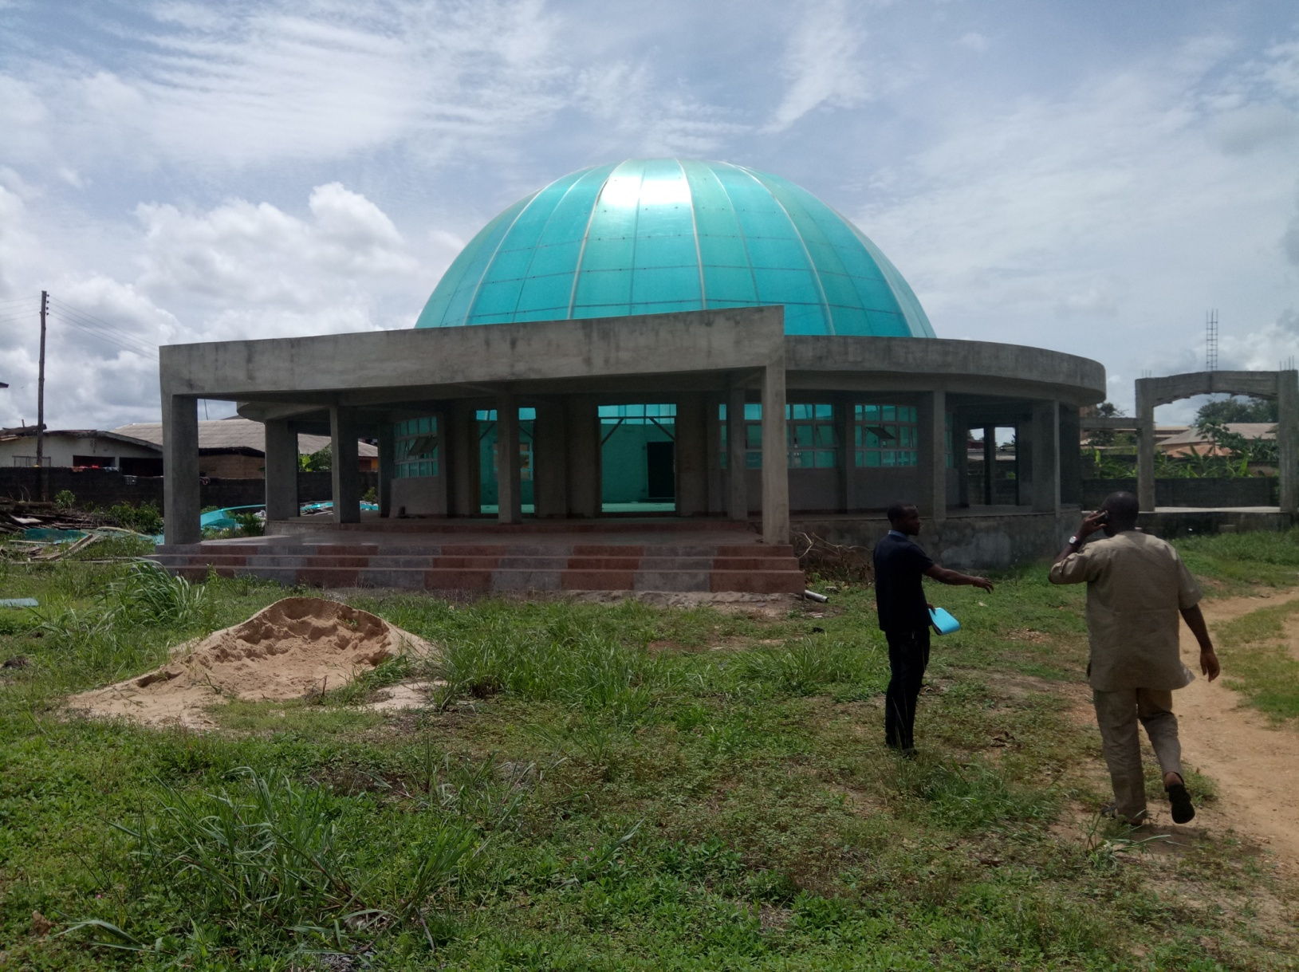

**CONSTRUCTION OF CHAPEL OF OUR LADY OF LIGHT, AGO-IWOYE**

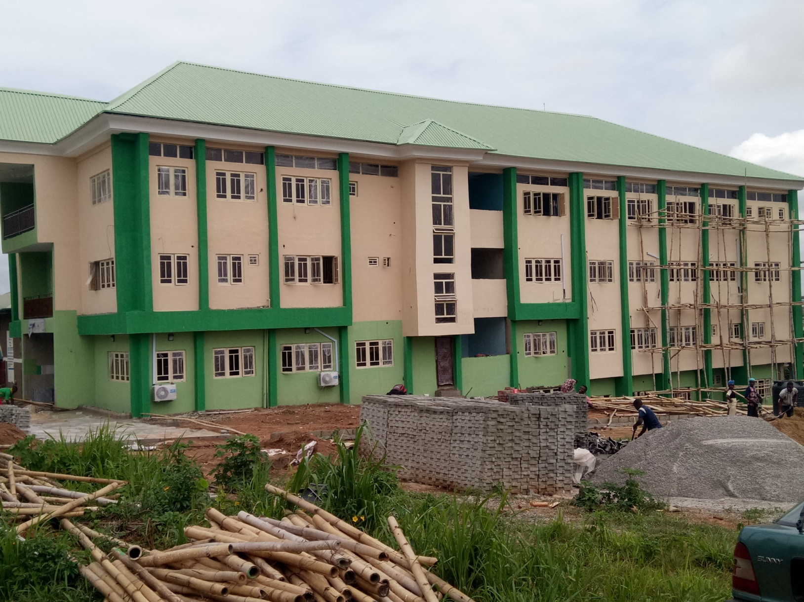

**CONSTRUCTION OF ELETA EYE INSTITUTE, ELETA, IBADAN**

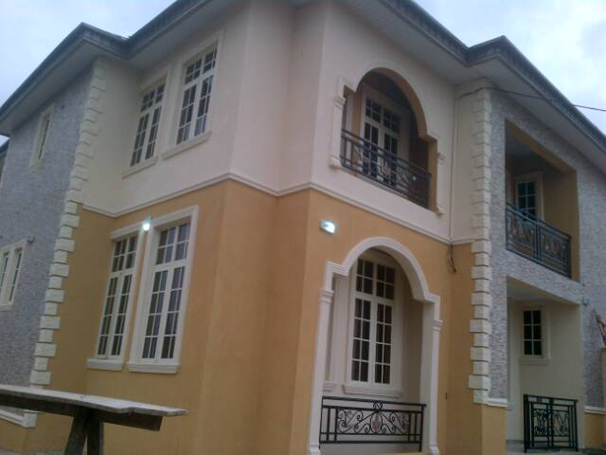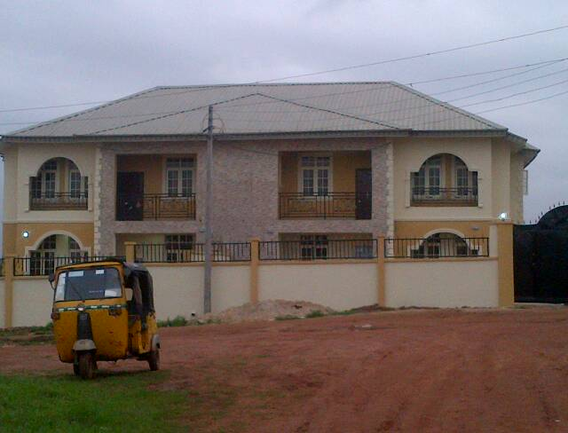

**CONSTRUCTION OF A TWIN DUPLEX AT IKORODU**

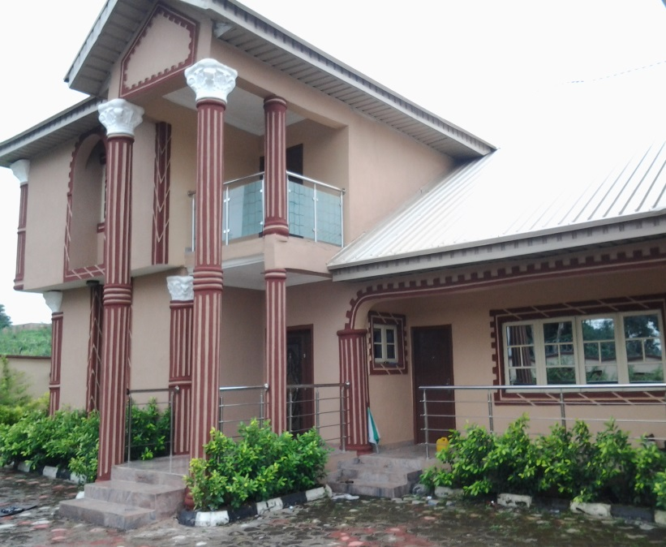

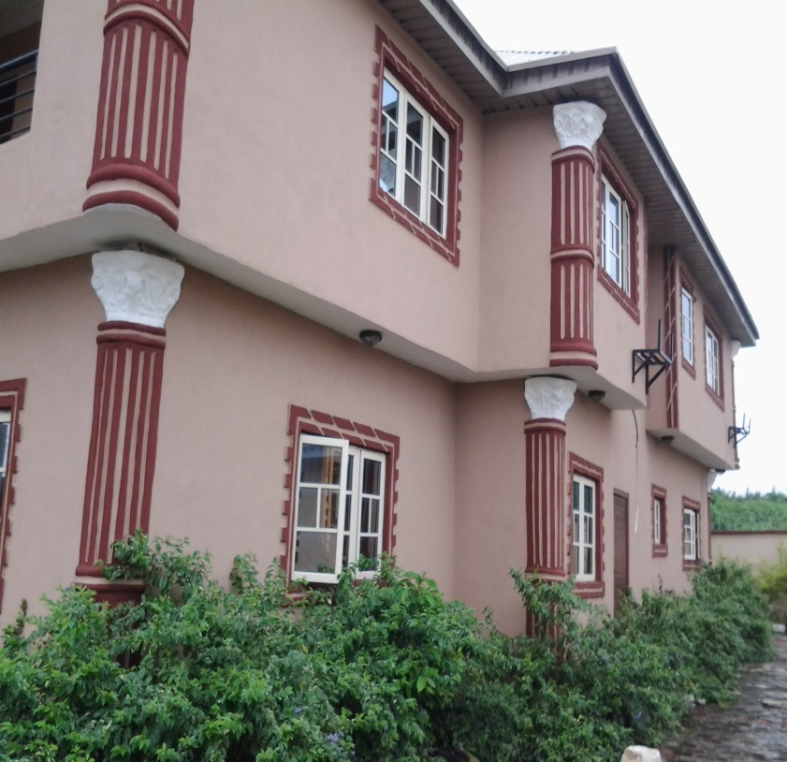

**CONSTRUCTION OF A DUPLEX AT KOLAPO ISHOLA ESTATE G.R.A IBADAN, OYO STATE**

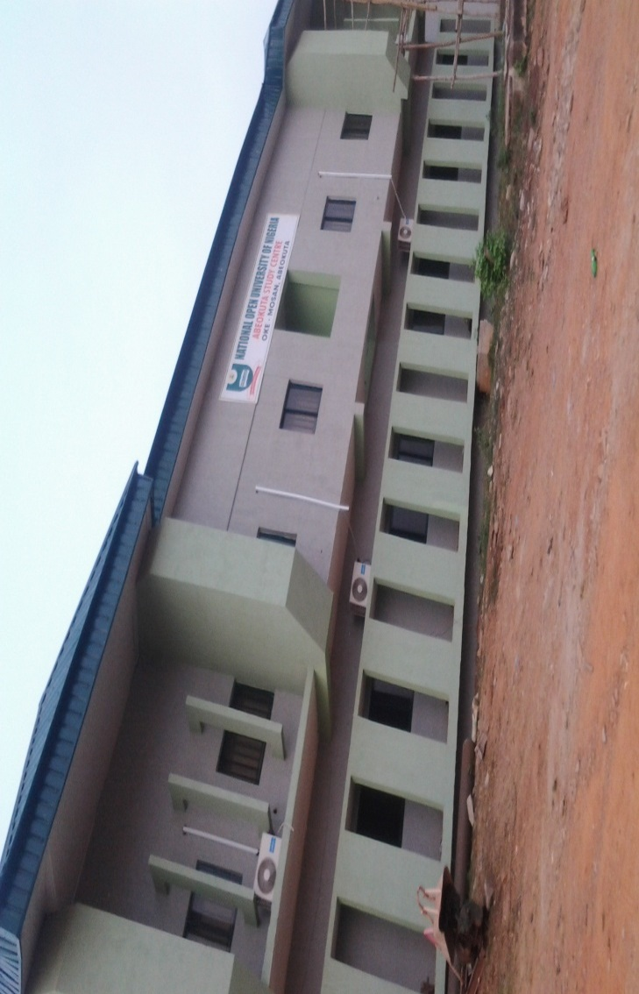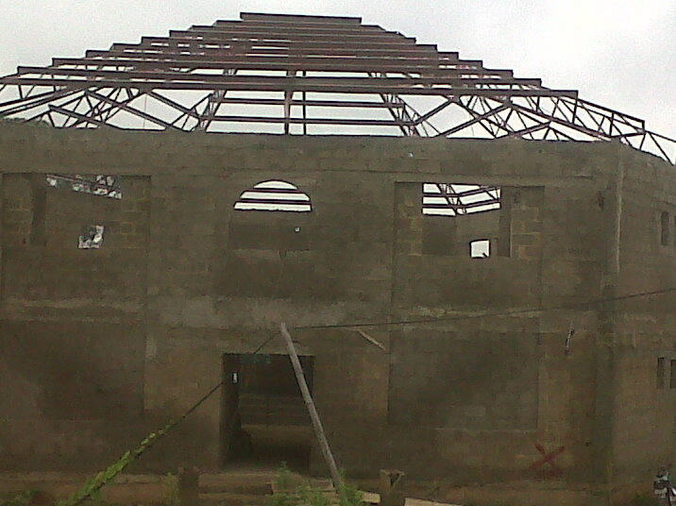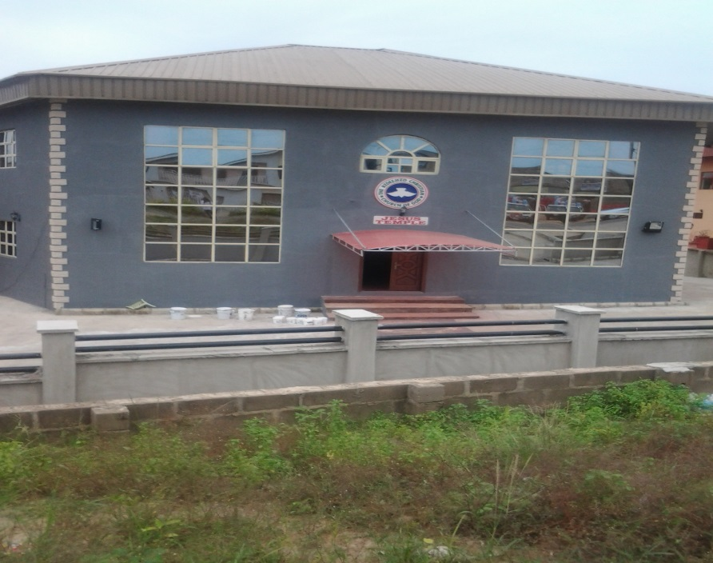

**CONSTRUCTION OF CHURCH AUDITORIUM AT AKOBO, IBADAN.**

**RENOVATION OF NATIONAL OPEN UNIVERSITY OF NIGERIA (NOUN), ABEOKUTA**

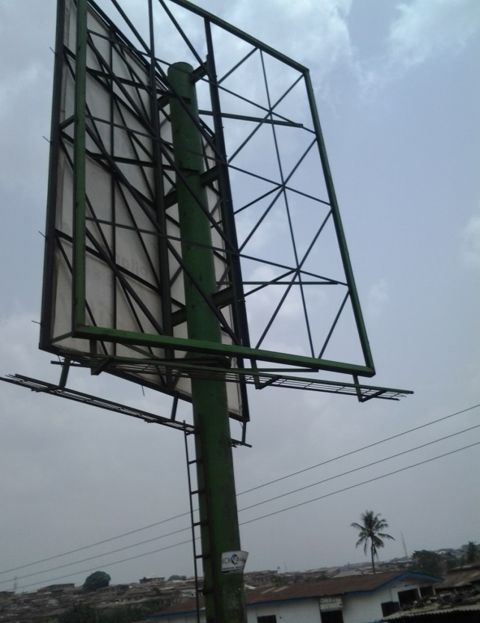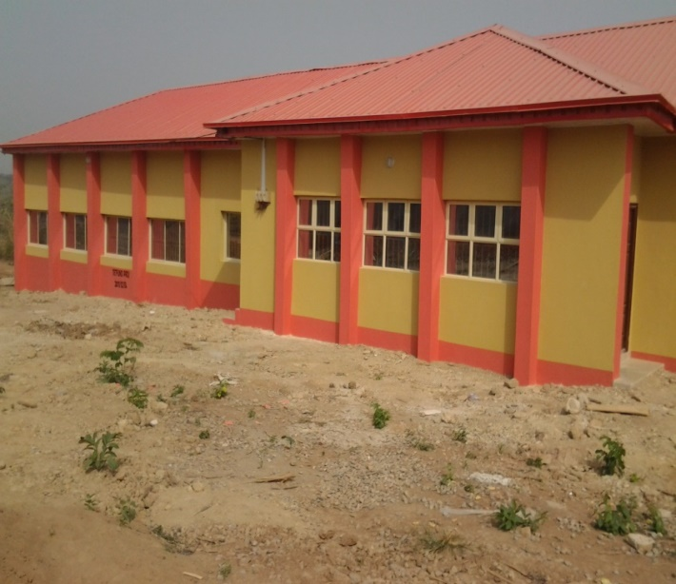

**CONSTRUCTION OF POTRAIT BOARD CONSTRUCTION OF NON-FORMAL AND ADULT**

**IDI – APE, IBADAN. EDUCATION LECTURE BUILDING**

**F.C.E OSIELE, ABEOKUTA.**

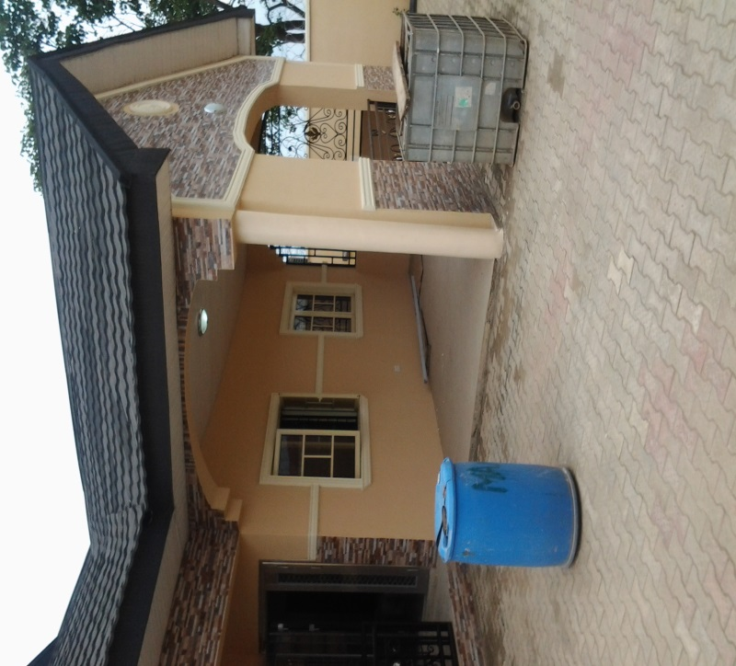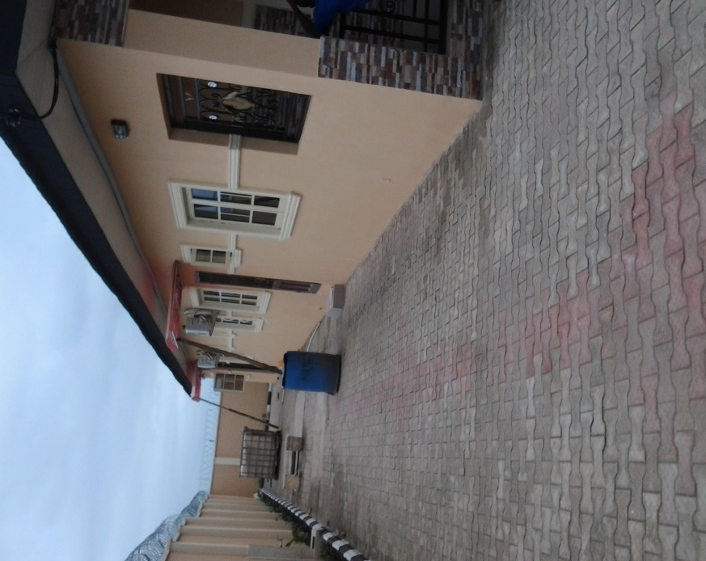

**CONSTRUCTION OF A BUNGALOW AT AKALA ESTATE IBADAN.**



**Akungba – Oka Road**



**Globalcom Mast at Ayanghene & Opella in Edo State**

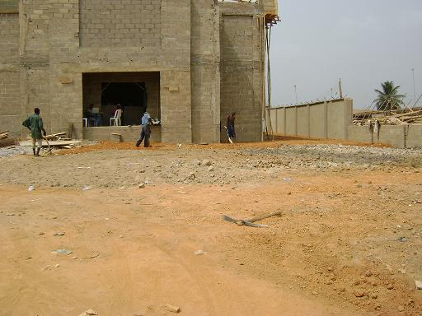

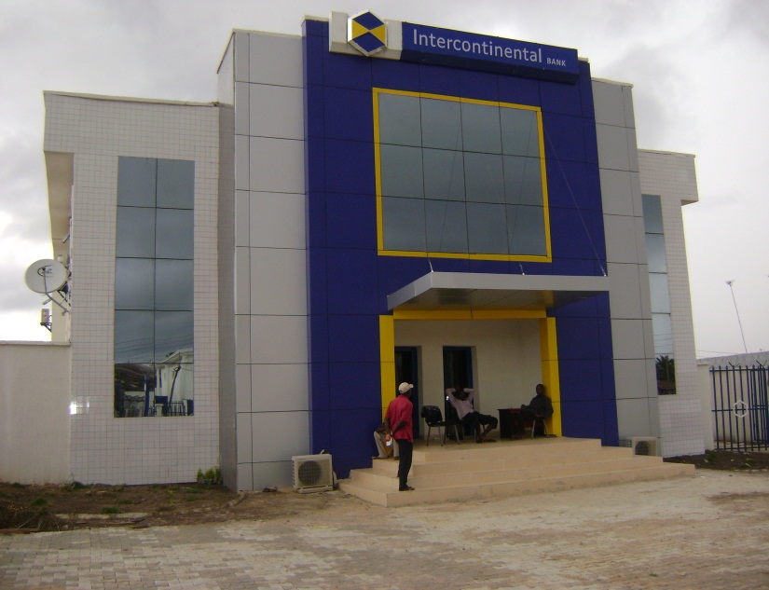

**CONSTRUCTION OF INTERCONTINENTAL BANK, ORE, ONDO STATE**



**Construction of Tantalizer Food Plc. Osogbo Outlet (Completed)**

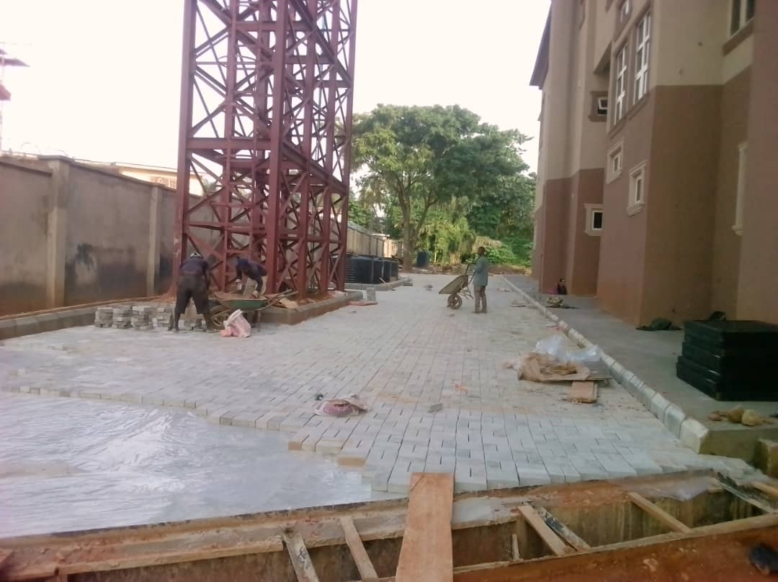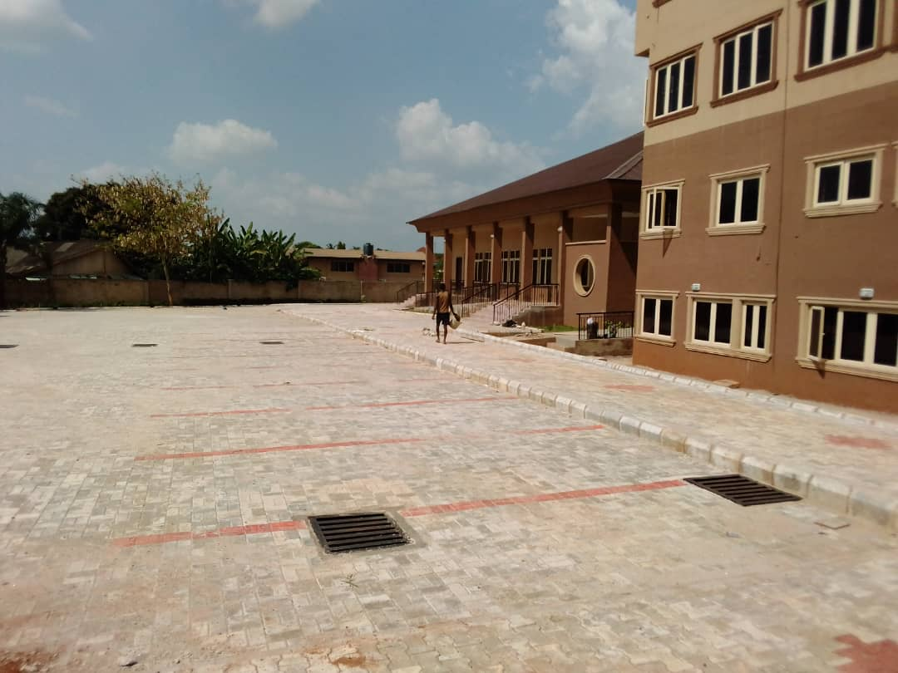

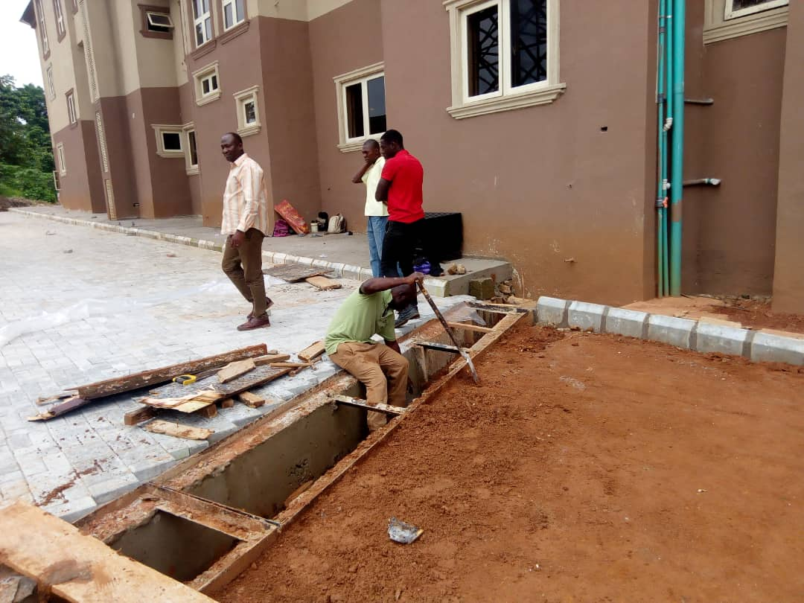

Control of flood and external works at (ola)

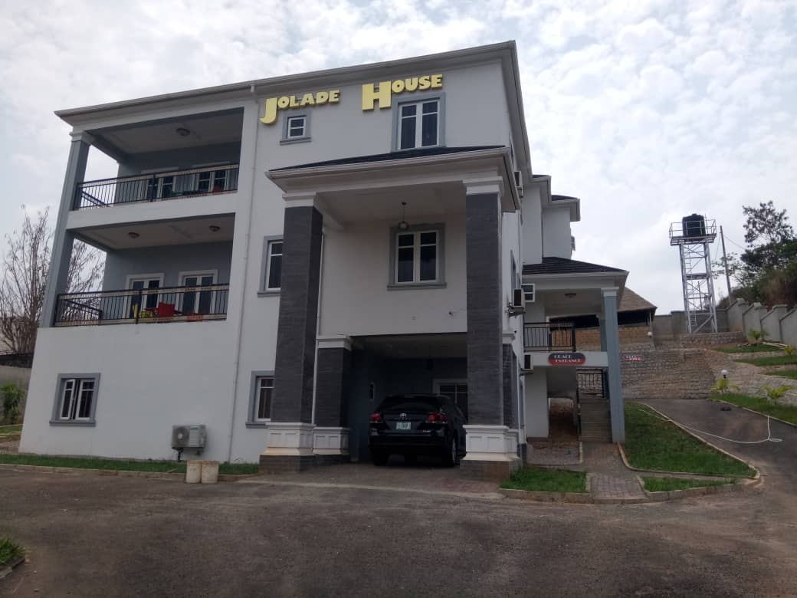

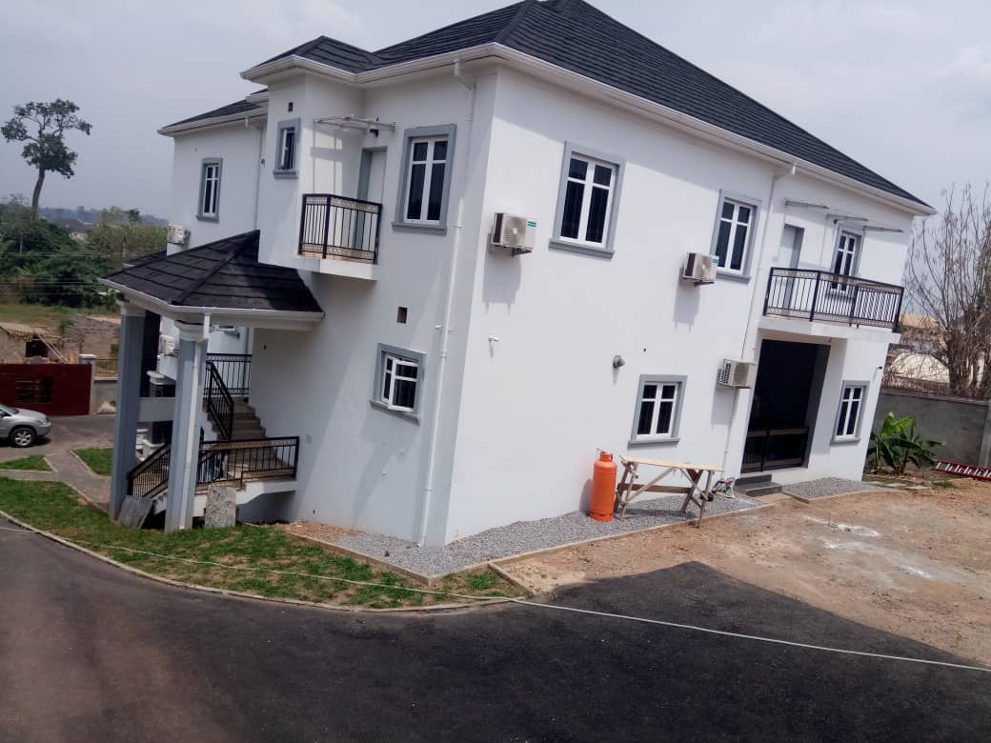

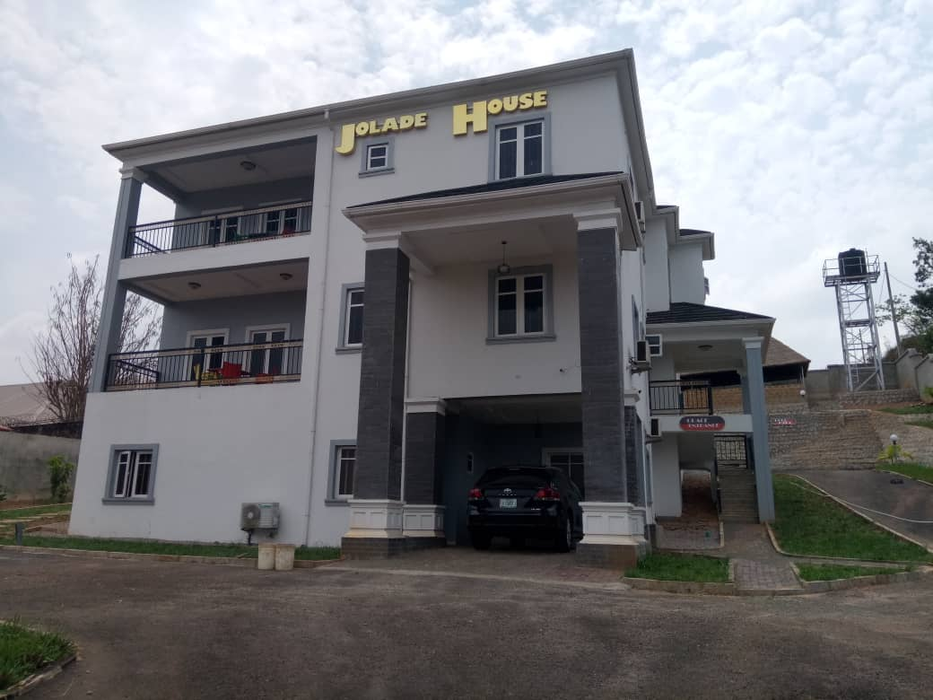

**CONSTRUCTION OF DUPLEX WITH BASEMENT IN AKURE**

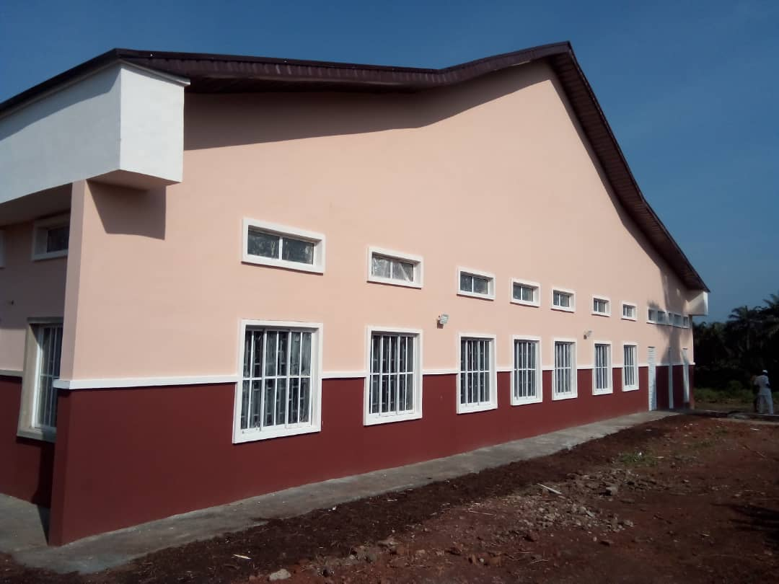

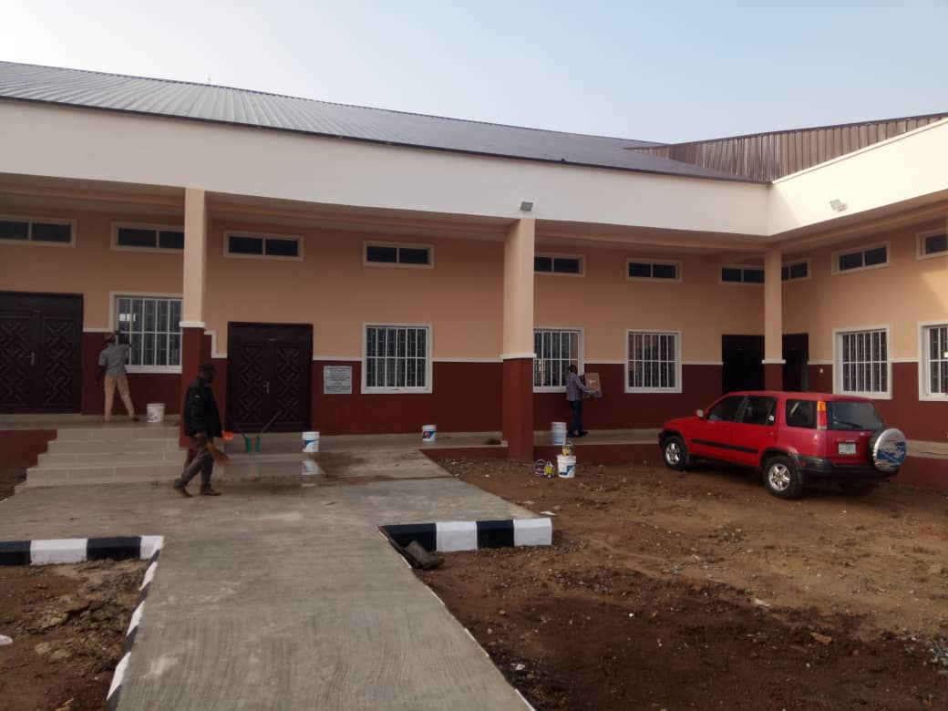

CONSTRUCTION OF ICT CENTER AT FEDERAL POLYTECHNIC ILE OLUJI



